**CONCUSSION POLICY**

The aim of this policy is to ensure that all players with a suspected concussion at Boyanup Hockey Club, at all levels, receive timely and appropriate advice and care to safely return them to everyday activities and hockey.

Concussion is a significant and complex health issue. This policy will enable club officials to know how to recognise and manage concussion at all levels of play. It will help players, coaches, officials and parents:

* understand what concussion is and why it is important, particularly for children
* recognise concussion
* manage a suspected concussion
* manage return to participation after concussion
* know where to get more information about concussion

Concussion is a disturbance in brain function rather than a structural injury to the brain. It is caused by direct or indirect force to the head, face, neck or elsewhere with the force transmitted to the head. A player does not have to be knocked unconscious to have a concussion. Loss of consciousness is seen in only 10–15% of cases of concussion.

Concussion is difficult to diagnose, and only medical doctors can definitively diagnose a concussion. However, recognising a suspected concussion at the time of injury is extremely important to ensure appropriate management and to prevent further injury.

Recovery from concussion varies from person to person, and injury to injury. If recognised and appropriately managed most people will recover from their symptoms.

# Who Gets Concussion?

Concussions occurs in almost every sport or recreational physical activity. It is more common in sports and activities with full physical contact between players (like the full contact football codes and combat sports like martial arts and boxing) or where players can hit their head forcefully on the ground (for example, snow sports, cycling, horse riding and skateboarding).

# RECOGNISING CONCUSSION

Although a medical practitioner should formally diagnose a concussion, all sport stakeholders including players, parents, coaches, officials are responsible for recognising and reporting players with visual signs of a head injury or who report concussion symptoms. This is particularly important when a medical practitioner is not at the venue. Watch for when a player collides with: another player; a piece of equipment; or the ground.

# Visual Signs

Players who sustain an impact to the head, face, neck, or body can demonstrate visual signs of a concussion such as:

* Lying motionless on the playing surface
* Getting up slowly after a direct or indirect blow to the head
* Being disoriented or unable to respond appropriately to questions
* Having a blank or vacant stare
* Having balance and coordination problems such as stumbling or slow laboured movements
* Having a face or head injury

# Symptoms

An athlete may report symptoms of a concussion to a teammate, parent, official or coach. Symptoms that suggest a concussion include:

* Headache
* Feeling “pressure in the head”
* Balance problems
* Nausea or vomiting
* Drowsiness
* Dizziness
* Blurred vision
* Sensitivity to light
* Sensitivity to noise
* Fatigue or low energy
* “Don’t feel right”
* Feeling more emotional than usual
* Being more irritable than usual
* Sadness
* Being nervous or anxious
* Neck pain
* Difficulty concentrating
* Difficulty remembering
* Feeling slow
* Feeling like “in a fog”

If the player answers any of these questions incorrectly, remove the player from the activity immediately. The player should not return to activity until assessed by a medical practitioner, even if they feel or appear okay.

# Memory Assessment

If a player is more than 12 years old, the questions listed can be used to recognise a suspected concussion.

An incorrect answer to any of these questions indicates the player may have sustained a concussion:

* “What venue are we at today?”
* “Which half is it now?”
* “Who scored last in the game?”
* “What team did you play last week/game?”
* “Did your team win the last game?”

Appropriately modified questions for younger children can include:

* “What month is it?”
* “What is the date today?”
* “What is the day of the week?”
* “What year is it?”
* “What is the time right now?”

In some cases, a player may have signs or symptoms of a severe head or spinal injury. These should be considered “Red Flags”.

If a player has any of the “Red Flags” set out below, a severe head or spine injury should be suspected.

# Red Flags include:

* Neck pain or tenderness
* Double vision
* Weakness or tingling/burning in arms or legs
* Severe or increasing headaches
* Seizure or convulsion
* Loss of consciousness
* Deteriorating consciousness
* Vomiting
* Increasing restless, agitation or aggression.

# Practice and Game Day Management

*If a medical practitioner is present at the Venue*

If there is a medical practitioner at the venue, they should assess the injured player. If they decide the player is concussed, the player must not resume participating on the same day, under any circumstances. The player must adhere to the return to participation protocols. If the medical practitioner decides the player is not concussed, the player can resume participating as soon as they feel ready. However, they should be monitored in case any signs or symptoms of concussion develop.

*If there is no medical practitioner present at the Venue*

If there is not a medical practitioner at the venue, once there has been recognition of signs and symptoms of a potential concussion, the player in question should be removed from play immediately and referral of the player to a medical practitioner for assessment should take priority. At this time, ensure the player is closely monitored and escorted for referral.

No one other than a medical practitioner can decide that it is okay for someone with suspected concussion to resume participating on the same day. This includes the player themselves, parents of junior players, coaches or officials.

A player who is removed from an activity because of a suspected concussion must not resume the activity for at least 48 hours, even if there are no signs or symptoms of concussion. An absence of signs or symptoms immediately after an incident is not a reliable indicator, because the signs and symptoms of a concussion may emerge up to 48 hours after the impact.

If an athlete is suspected of sustaining a severe head or spinal injury (“Red Flag”), call an ambulance immediately.

# Removal from Play & Immediate Management

Initial management must adhere to first aid rules, including airway, breathing, circulation and spinal immobilisation.

Anyone with a suspected concussion must be removed from the game. This will enable the player to be properly assessed. Anyone who has a suspected concussion must not be allowed to return to participation in the same game/day unless cleared by a medical practitioner. Do not be influenced by the player, coaching staff, parents or others suggesting that they should return to play.

Players with suspected concussion should:

* Be immediately removed from participation
* Not be left alone initially (at least for the first 1–2 hours)
* Not drink alcohol
* Not use recreational drugs
* Not take certain prescription medications including aspirin, anti-inflammatory medications, sedative medications or strong pain-relieving medications
* Not be sent home by themselves
* Not drive a motor vehicle
* Be referred for appropriate medical assessment

If the player is a child, inform the parents of the situation as quickly as possible. Tell them that appropriate medical assessment, rest and supervision is required.

# Concussion in Children and Adolescents

The management of sport related concussion in children (aged 5 to 12 years) and adolescents (aged 13 to 18 years) requires special paradigms suitable for the developing child. Children have physical and developmental differences - less developed neck muscles; increased head to neck ratio; brain cells and pathways that are still developing. Children and adolescents may have greater susceptibility to concussion, they may also take longer to recover, and they may be at risk of severe consequences such as second impact syndrome. Managing concussion in children and adolescents therefore requires different standards and a more conservative approach. Children typically take longer to recover from concussion than adults (up to four weeks).

# Return to Learn

The priority when managing concussion in children should be returning to school and learning, ahead of returning to hockey. Concussion symptoms can interfere with memory and information processing. This can make it hard for children to learn in the classroom. Parents should discuss with their doctor and child’s school, an appropriate return to school strategy.

# Rest and Recovery

Most people will recover from a concussion within 10 to 14 days. However, recovery will vary from person to person, and from injury to injury. Children and adolescents often take longer to recover from a concussion than adults, and it is not abnormal for symptoms to last up to 4 weeks for children or adolescents.

For children and adolescents, it is suggested the graduated return to play protocol should be extended such that a child does not return to contact/collision activities less than 14 days from the resolution of all symptoms.

Rest is recommended immediately following a concussion (24–48 hours). Rest means not undertaking any activity that provokes symptoms. However, anyone who has suffered a concussion should be encouraged to become gradually and progressively more active if they do not experience any symptoms.

Always refer the player and, if they are a child, their parents, to a medical practitioner with some expertise in the management of concussion.

# Return to Play

Managing concussion is a shared responsibility between the player, coach, parents and medical practitioner. Open communication is essential, and information should be shared. Coaches, administrators and officials should provide players and their parents with information about the:

* immediate management of a suspected concussion;
* graduated return to participation protocol;
* medical clearances needed to return to participation.

Always refer the player and, if they are a child, their parents, to a qualified medical practitioner with some expertise in the management of concussion.

A player who has suffered a concussion should return to hockey gradually. If they remain symptom free, they should increase their exercise progressively, following the stages outlined below:

Following 24–48 hours of physical and mental rest stage:

1. Daily activities while remaining symptom-free
2. Light aerobic exercise
3. Hockey specific exercise
4. Non-contact training drills

# Activity

Daily activities that do not provoke symptoms:

Walking, swimming or stationary cycling at a slow to medium pace. No strength or weight training.

Running drills in football or drills in hockey. No activities with potential for head impact. Harder training drills, e.g. passing etc.

Start progressive strength or weight training.

Each stage of the progression should take at least 24 hours. If any symptoms worsen during exercise, the athlete should go back to the previous stage. Strength or weight training should be added only in the later stages (3 or 4 at the earliest).

If symptoms persist - more than 10–14 days in adults or more than 4 weeks in children/ adolescents - refer the player to a medical practitioner with expertise in managing concussion.

This policy has been adapted from Sports Medicine Australia’s recommendation. Further information and useful resources can be found at <https://www.concussioninsport.gov.au/coaches_and_support_staff#sporting_code_policies>

The following flowcharts are available online at the above Concussion in Sport website.

# Concussion Recognition Tool

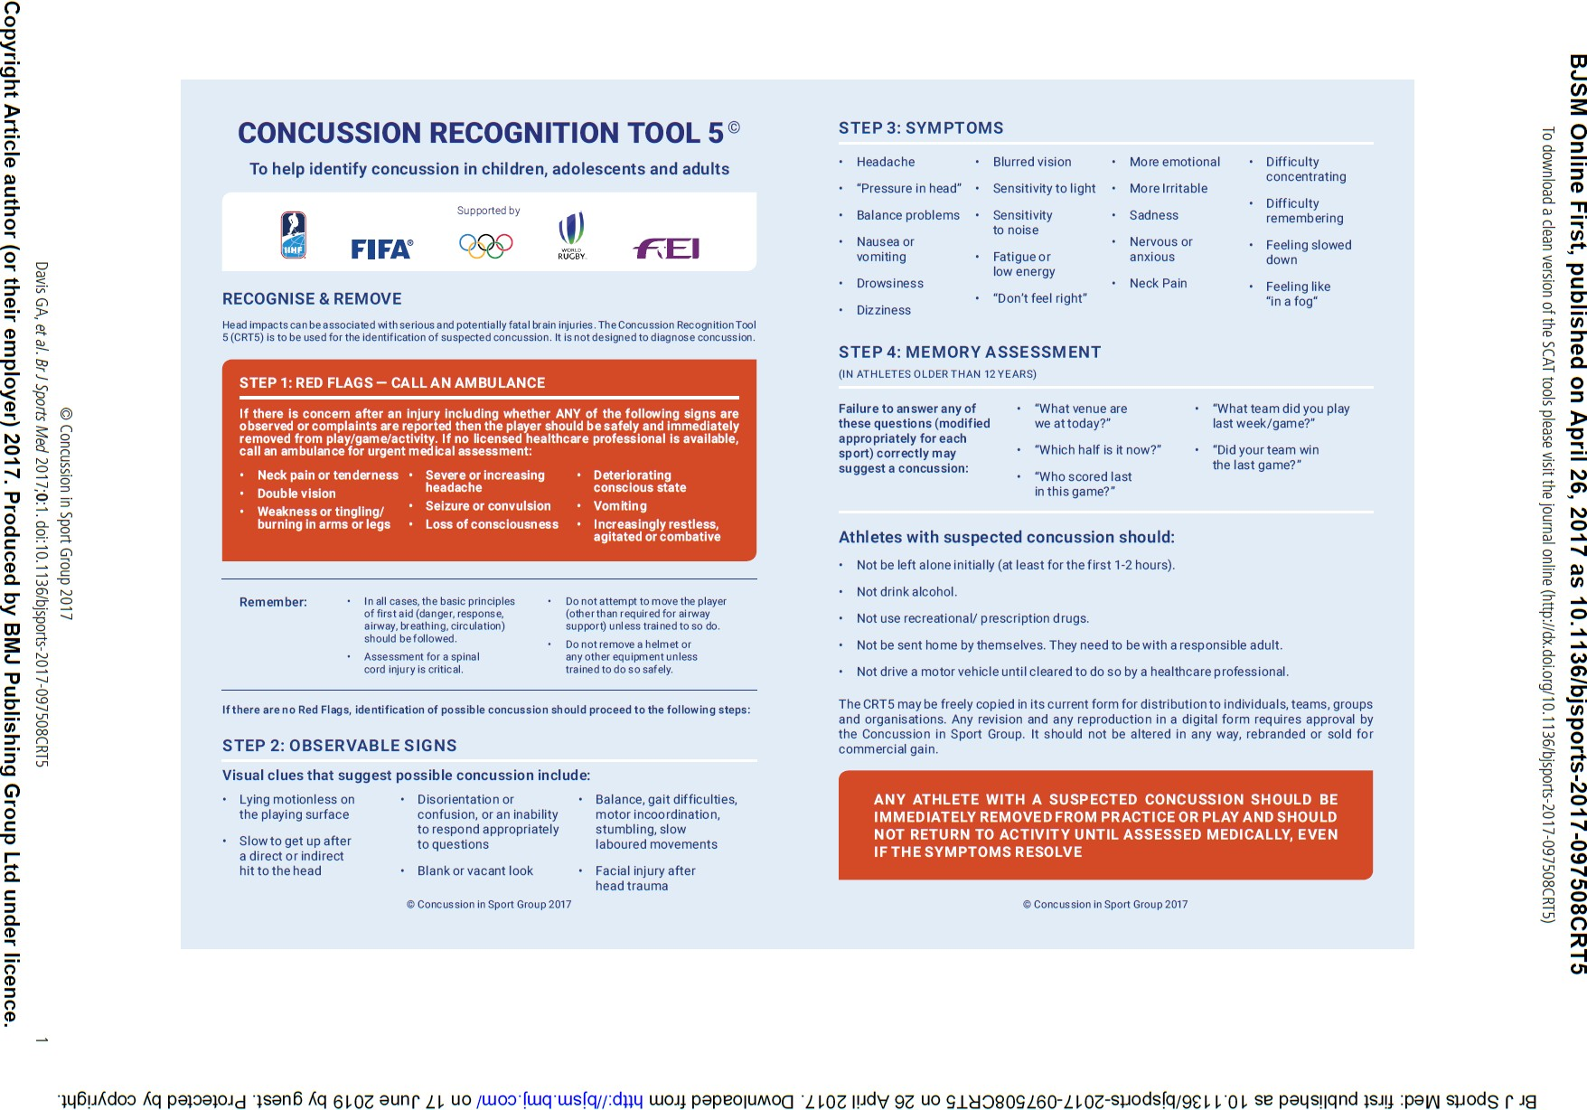

**Concussion Management Flowchart – On Field**

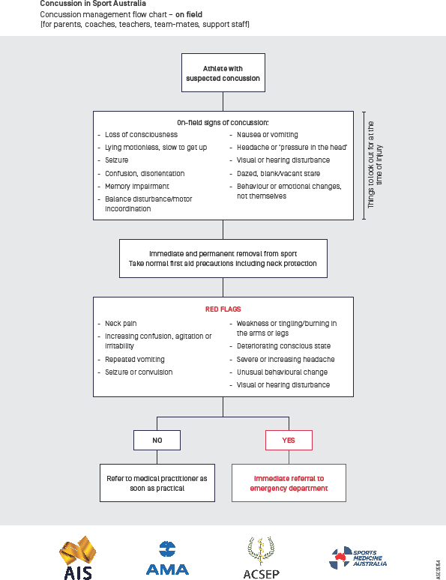

**Concussion Management Flowchart – Off Field**

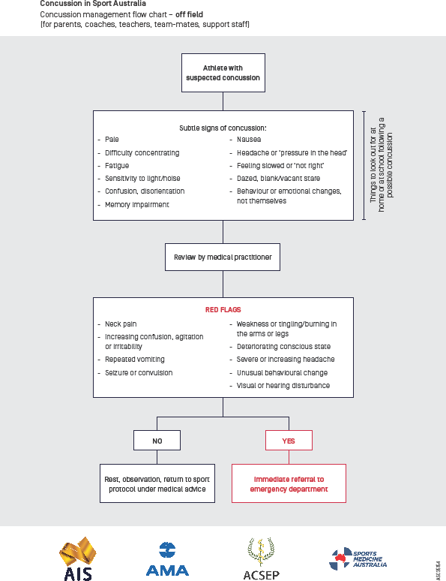

**Return to Sport Protocol for Children 18 years of age and under**

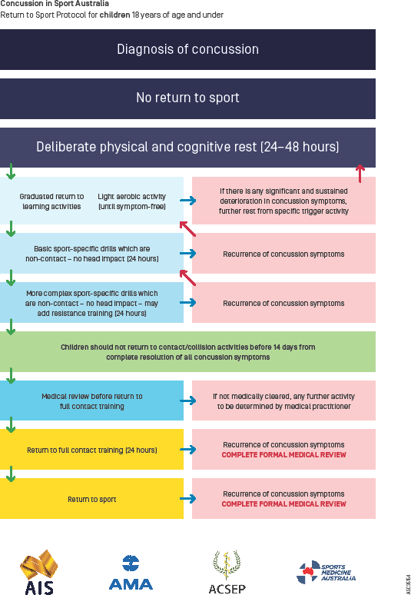

**Return to Sport Protocol for Adults over 18 years of age**

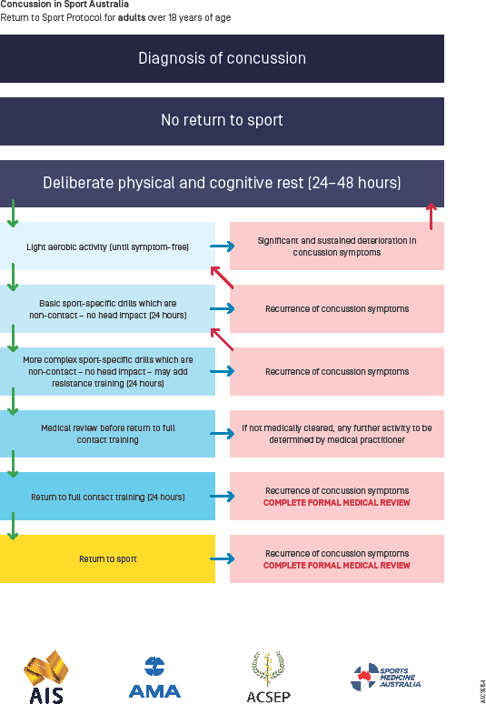

**Concussion in Sport Information Summary**

